ConnectX Networking Report
Course: Networking
Assignment Title: ConnectX Company Network
Student Name: Nour Akram Adnan Atiya
Student ID: 24120026
Submission Date: 13/06/2025

SECTION A – NETWORK DESIGN
1. Network Planning
I planned the network using subnetting to divide the LAN into smaller subnets that allow up to 30 hosts per branch. Each branch and department use a /27 subnet, giving 30 usable IPs.

1.1 LAN Subnets:

Location | Subnet | IP Range | Gateway IP
Amman (HQ) | 192.168.1.0/27 | 192.168.1.1 – 192.168.1.30 | 192.168.1.1
Amman LAN2 | 192.168.1.32/27 | 192.168.1.33 – 192.168.1.62 | 192.168.1.33
Irbid | 192.168.1.64/27 | 192.168.1.65 – 192.168.1.94 | 192.168.1.65
Zarqa | 192.168.1.96/27 | 192.168.1.97 – 192.168.1.126 | 192.168.1.97
Aqaba | 192.168.1.128/27 | 192.168.1.129 – 192.168.1.158 | 192.168.1.129
Beirut | 192.168.1.160/27 | 192.168.1.161 – 192.168.1.190 | 192.168.1.161
Cairo | 192.168.1.192/27 | 192.168.1.193 – 192.168.1.222 | 192.168.1.193

Location | Network IP | Broadcast IP
Amman (HQ) | 192.168.1.0 | 192.168.1.31
Amman LAN2 | 192.168.1.32 | 192.168.1.63
Irbid | 192.168.1.64 | 192.168.1.95
Zarqa | 192.168.1.96 | 192.168.1.127
Aqaba | 192.168.1.128 | 192.168.1.159
Beirut | 192.168.1.160 | 192.168.1.191
Cairo | 192.168.1.192 | 192.168.1.223

1.2 Subnet Size and Justification
To meet the requirement of supporting up to 30 users per site, we used /27 subnetting.
A /27 subnet provides:
- 32 total Ips
- 30 usable Ips
- 1 network address
- 1 broadcast address
1.3 WAN Subnets (/30):
Each router-to-router connection uses a /30 subnet, which provides just 2 usable IPs—perfect for point-to-point links.
1.4 Loopback (/32):
Each router has a unique loopback IP for use as the OSPF Router ID.
IP Block | Purpose | Subnet Used | Reason
100.0.0.0/8 | WAN links | /30 | 2 usable IPs per router link
50.0.0.0/8 | Loopback addresses | /32 | 1 IP per router (OSPF Router ID)
So, while (/8) is the total range I am working from, but we subnet it into (/30) and (/32) based on what the company needs.

2. Design Blueprint
I used a ring topology with a mix of partial mesh for router connections. This ensures redundancy and reliable communication between all branches and the headquarters.
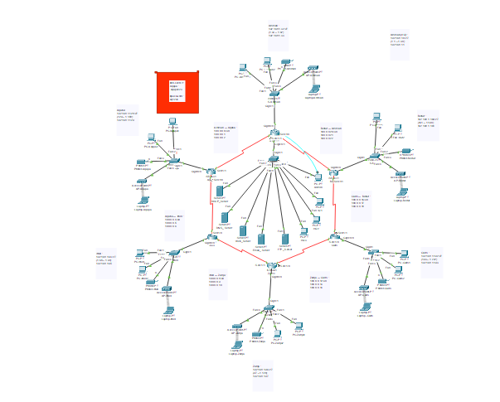

Feature | Description
Ring Topology | Routers are connected in a ring loop
Star Topology | Each office uses a simple star topology where all devices connect to a switch

2.2 Why I Chose This Design
- Redundancy: If one WAN link fails, data can still go around the ring in the other direction.
- Scalability: Easy to add new branches and end devices.
- Simplicity: Star layout making it easy to manage.
- Efficiency: Amman HQ has direct links to two cities to improves speed.

3. Device Configuration
3.1 IP Address Assignment: Static vs Dynamic
- Static IPs: used when the device provides a service or needs to be easily reachable.
- Dynamic Ips: used for client devices to reduce manual configuration.

Device Type | IP Type | Reason
Routers | Static | Ensures reliable communication and routing
Servers | Static | It is needed for fixed services I used like: DHCP, DNS, Web, and FTP.
Printers | Static | Easy to locate and share
PCs & Laptops | Dynamic | Easier to manage via DHCP
Loopback Interfaces | Static | Used in OSPF because it must remain stable
Admin pc | Static | to ensure consistent network access for management tasks.

3.2 Routing Protocols – OSPF vs RIP
Feature | OSPF (Used) | RIP
Protocol Type | Link-State | Distance-Vector
Convergence Speed | Fast | Slow
Scalability | Highly scalable | Limited to 15 hops
Use Case | Medium to large networks | Small, simple networks

3.3 Why I Chose OSPF:
- Faster convergence
- Better scalability (supports large networks)
- Cost-based metric (not just hop count)
- VLSM support and loop prevention mechanisms

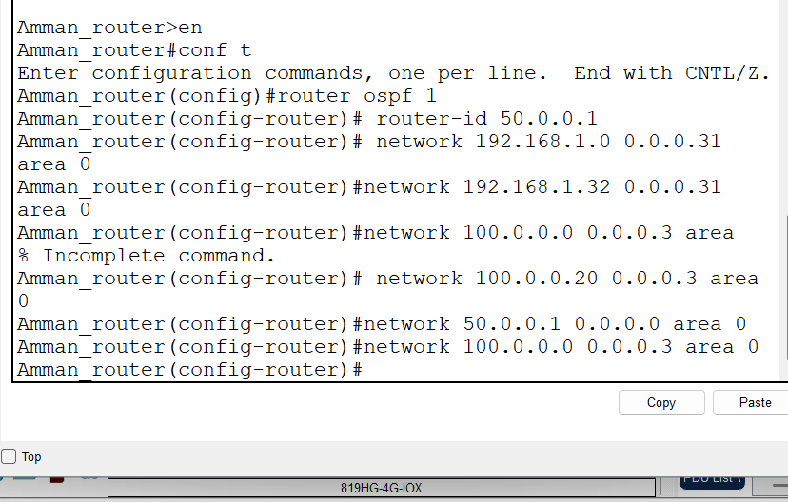

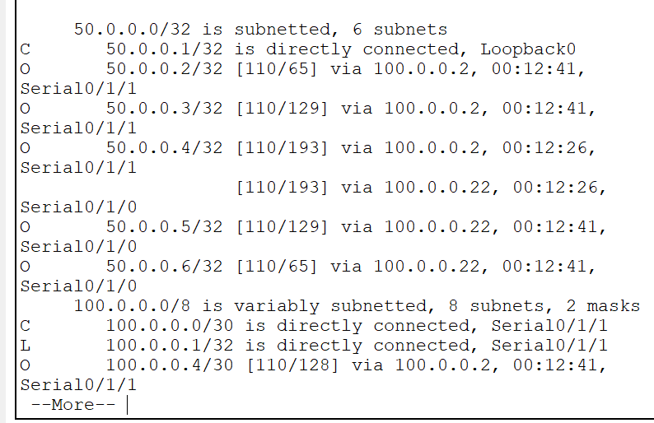

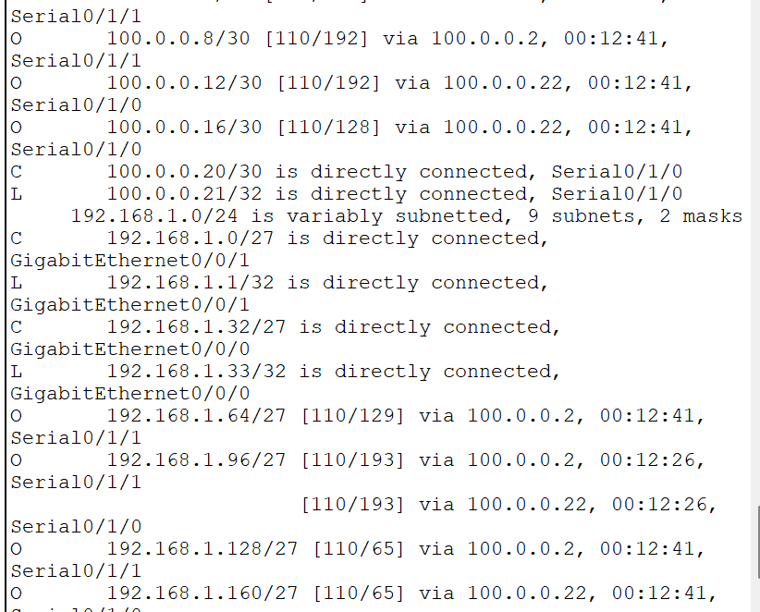

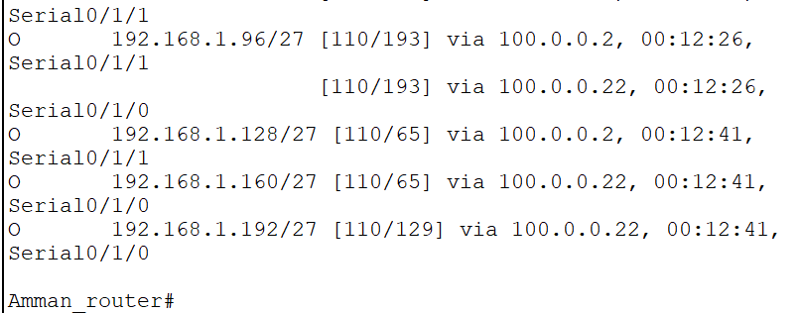

3.4 Security Configuration Used
I configured basic security settings on the Aqaba router:
enable secret aqapa123 line console 0 copy running-config startup-config
password aq1234
login
- Enable secret: Sets a secure password and configured to protect access to privileged EXEC mode, ensuring administrative control remains restricted
- password: defined to secure remote access to the device via virtual terminal lines, if remote login is enabled.
- So, that means to use enable secret for all admin-level access, and use password under console lines for terminal and remote logins
- copy running-config startup-config: command used to save the current configuration on the device.

4. Server Installation & Services
Server | Role | IP Address | Purpose recording to the company
Server1 | DHCP | 192.168.1.2 | Automatically assigns dynamic IPs to PCs across all branches, reducing manual configuration
Server2 | DNS | 192.168.1.3 | Translate domain name to IP address
Server3 | Web | 192.168.1.4 | Host ConnectX’s secure internal web portal (HTTPS)
Server4 | Email | 192.168.1.5 | Internal email system for all offices which Enables staff to communicate
Server5 | FTP | 192.168.1.6 | File sharing across all branches and HQ

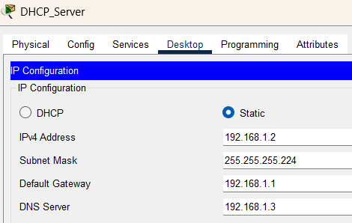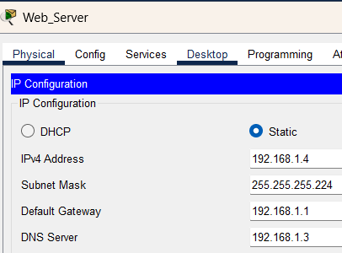

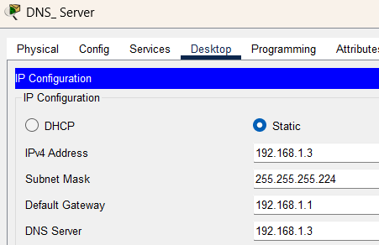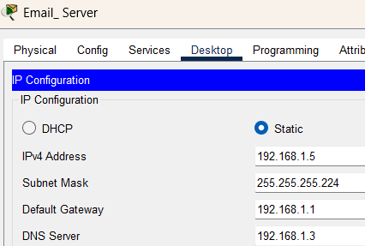

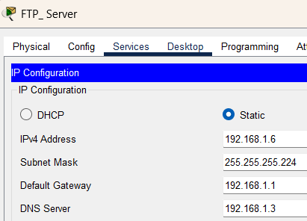

5. Test Plan
Test | Test Objective | Test Method / Tool | Devices Involved (Example) | Expected Result
T1 | Check inter-branch connectivity | ping command | PC in Irbid ↔ PC in Beirut | Ping successfully
T2 | DHCP functionality | Auto_config | PCs in Aqaba and Zarqa | IPs are automatically assigned from correct DHCP pools I give
T3 | Test DNS name resolution | Browser | Any PC/ laptop → DNS server at 192.168.1.3 | eis.connectx.com resolves to 192.168.1.4 (Web Server)
T4 | Access the website | Web browser | Any PC / laptop → Web Server | Website loads with HTTPS (https://eis.connectx.com)
T5 | Send and receive internal emails | Email client | BeirutStaff → HQEmployee | Email is successfully delivered, received and replied
T6 | Upload and download files via FTP | FTP client | Admin PC ↔ FTP Server | Files transfer without error
T7 | OSPF neighbor | show ip ospf neighbor | All routers | OSPF adjacent is established and stable

6. Maintenance Schedule
Time Frame | Task | Purpose
Weekly | Check connectivity between routers and devices | Ensure network stability and detect issues early
 | Monitor network traffics | Detect unusual activity, prevent early signs of attacks
 | Review system logs (routers, switches, servers) | Identify potential system faults or errors
 | Backup configuration files (routers/switches) | Prevent config loss due to human error or failure
 | Test DHCP, DNS, Web, Email services | Confirm essential network services are up and functioning
 | Update antivirus/anti-malware definitions | Stay protected
 | Review of DHCP lease tables | Detect and prevent IP conflicts
Monthly | Apply OS and firmware updates | Patch security and enhance performance
 | Audit user accounts on all servers | Remove outdated users and tighten access control
 | Test data backup restoration | Ensure backup recovery procedures are effective
Yearly | Conduct full disaster recovery drill | Prepare for major outages or data loss
 | Evaluate IP addressing and subnet allocation | Improve address planning and scalability
 | Replace outdated or end-of-life hardware | Maintain reliability and improve performance
 | Review and renew software licenses | Ensure compliance and vendor support
 | Scale server resources (CPU, RAM, storage) | Support future growth and performance needs
 | Review vendor support and maintenance contracts | Ensure timely support and cost-effective service agreements

7. Evaluation of Topology and Protocol
7.1 Logical Topology Used: Hybrid Ring with Partial Mesh
In the ConnectX network, the logical topology is based on a hybrid structure:
- Ring: The branch routers are connected in a circular loop (Aqaba → Irbid → Zarqa → Cairo → Beirut → back to Amman).
- Partial Mesh: Amman HQ connects directly to Aqaba and Beirut, giving it faster access to both southern and northern sides which give Direct paths to/from HQ reduce latency and simplify data access.
- This gives balance, fault tolerance and cost-efficiency.
7.2 Routing Protocol Used: OSPF (Open Shortest Path First)
We used OSPF across all routers. OSPF is a link-state routing protocol that:
- Build a full map of the network using Link State Advertisements.
- Calculates the shortest and most efficient path using Dijkstra's algorithm.
- Uses cost-based metrics, not just hop count.
7.3 Example from ConnectX Topology:
- The Amman router has two WAN links (to Aqaba and Beirut), which:
  - Improve speed for accessing southern and northern branches
  - Reduce dependency on one route
- If the link Aqaba → Irbid fails, traffic reroutes via Amman → Beirut → Cairo → Zarqa → Irbid
- OSPF recalculates the route automatically and quickly users will barely notice the switch

7.4 How This Design Improves the Network
Factor | Impact
Scalability | OSPF supports large hierarchical networks. New branches can be added easily by configuring new areas or adding
Performance | OSPF converges quickly if a link fails, it recalculates routes efficiently using SPF algorithm
Resource Utilization | Traffic is optimized using cost-based metrics, preventing slow or overloaded links. Also, loopback interfaces provide stable router IDs
Load Balancing | supports equal-cost multi-path (ECMP)

8. Server Type Justification
Server Role | Hardware | Specs | OS | Cost (USD)
DHCP | HPE MicroServer Gen10 Plus (tower) | Intel Xeon E-2224, 16 GB RAM, 250 GB SSD | Ubuntu Server 22.04 LTS | $600–$700
DNS | Dell PowerEdge T40 (tower) | Intel Xeon E-2224G, 16 GB RAM, 250 GB SSD | Ubuntu Server 22.04 LTS | 600–$800
Web | Dell PowerEdge R340 (1U rack) | Intel Xeon E-2236, 32 GB RAM, 500 GB SSD RAID-1 | Ubuntu Server 22.04 LTS | $800–$1,100
Email | Dell PowerEdge R540 (2U rack) | 2× Xeon Silver, 64 GB RAM, 1 TB SSD RAID-1 | Ubuntu Server 22.04 LTS | $700–$1,200
FTP | Lenovo ThinkSystem ST50 (tower) | Intel Xeon E-2226G, 32 GB RAM, 2 TB HDD RAID-1 | Ubuntu Server 22.04 LTS | $800–$1,000

Server Type | Why it fit ??
HPE MicroServer Gen10 Plus (for DHCP) | Compact, low-power, ideal for lightweight roles like DHCP. Enterprise-grade with ECC memory support.
Dell PowerEdge T40 (for DNS) | Reliable tower server with low cost, perfect for BIND DNS. Easy to manage, no overkill.
Dell R340 (for Web) | Handles moderate heavy web traffic. RAID setup adds fault-tolerance for your website.
Dell R540 (for email) | Powerful and scalable. Can manage multiple mailboxes, spam filtering, storage growth.
Lenovo ST50 (for FTP) | Tower server with large storage and RAID. Good performance and protection for shared files.

>>Total Adjusted Estimated Cost: $3,500–$4,800 USD
This range reflects market prices. It maybe seems vary, but these are realistic and supported by market listings. It gives you dedicated performance, long-term reliability, and centralized control — while staying affordable and ready for growth.

9. Hardware & Software Interdependency
A message is sent from Device A (a PC in Aqaba branch) to Device B (a Web Server at Amman HQ) to access the HTTPS site (https://eis.connectx.com).
OSI Layer | Function | What Happens (Encapsulation/De-encapsulation) | Example in ConnectX
7. Application | User-facing apps like browsers, email, FTP | The message is created (e.g., HTTP GET request). No real "encapsulation" yet — just user data. | PC browser opens https://eis.connectx.com
6. Presentation | Data formatting, encryption, compression | Data is converted into a format that can be understood by both ends | HTTPS encrypts the web request
5. Session | Starts and manages communication sessions | Establishes a session between client and server, handles login, handshakes. | Secure HTTPS session begins
4. Transport | Ensures reliable data transfer (TCP/UDP) | Message is broken into segments, headers added | Uses TCP port 443 for HTTPS
3. Network | Handles addressing and routing | Data becomes packets, IP headers are added (source/destination IP). | PC’s IP: 192.168.1.130; Web Server: 192.168.1.4
2. Data Link | Communication within the same LAN | Converts packets into frames; adds MAC addresses for the next hop. | Switch adds MAC info to reach gateway router
1. Physical | Moves bits over cables or wireless | Converts frames into bits (0s and 1s), transmits as electric signals. | Ethernet cables send the signal to Aqaba router
9.2 Message on the Way (Encapsulation)
When Device A sends the message (a PC in Aqaba branch).
9.3 Message Received (De-encapsulation)
When Device B sends or replies (Web Server in Amman)

9.4 Ensuring Successful Delivery in ConnectX
Layer | Key Role in Delivery
L1 – Physical | Sends raw bits/signals over cable (0s and 1s)
L2 – Data Link | Checksum / FCS for error detection in frames
L3 – Network | IP addressing, TTL, and ICMP for routing and error reporting
L4 – Transport | Acknowledgment, Sequence numbers, Retransmission, Checksum
L5 – Session | Manages session start, sync, and close
L6 – Presentation | Encryption / Decryption
L7 – Application | Confirms delivery through service response

SECTION B – IMPLEMENTATION & ENHANCEMENT
1. Test Execution
Test | Test Description | Expected Result | Actual Result | Status | Troubleshooting (if failed)
T1 | Check inter-branch connectivity via ping | Ping success between PC in Irbid and Beirut | Ping successfully | pass | _
T2 | DHCP functionality in Aqaba & Zarqa | PCs should receive IPs via DHCP from server at HQ | PCs received APIPA (169.x.x.x), DHCP failed | Fail | Added IP helper-address 192.168.1.2 on routers’ LAN interfaces.
T3 | DNS name resolution | Typing hostname (e.g., admin) resolves to correct IP | Resolved to correct IP after fixing DNS config | Pass | _
T 4 | Access internal website via browser | Website loads using https://eis.connectx.com | Website loaded via browser with secure HTTP | pass | _
T5 | Send/receive internal emails | Beirut staff sends emails to HQ employees, reply works | Send worked but reply failed | Fail | Corrected DNS hostname, SMTP/POP3 settings,
T6 | FTP upload between Admin and FTP Server | Admin PC uploads and downloads files successfully | Files transferred correctly | Pass | _
T7 | OSPF neighbor formation | All routers form neighbor via OSPF | Missing neighbors at first | Fail | Configured OSPF on all routers, assigned Router loopbacks IDs

2. Enhancement Plan
2.1 Weaknesses need to be solved:
The current network lacks essential security measures at the router level, leaving it susceptible to unauthorized access and potential misuse by internal users.
- No VLANs implemented
- No firewall rules
- Lack of Access Control Lists (ACLs): No restrictions between branches; all branches can access all services by default, which can be a security risk.
- No Backup DHCP: Only one DHCP server at HQ—if it goes down, no dynamic IP assignment.
2.2 Proposed Enhancements
1. Security Enhancements:
- Create extended ACLs on router interfaces to restrict unnecessary traffic. So that will Limits traffic based on source, destination, and protocol.
- Plan for VPN Encryption (IPsec) that Protects data in transit, especially for sensitive government or financial data.
- Firewall Appliances to Deploy dedicated firewall appliances (e.g., Cisco Firepower) and transparent or routed mode depending on the branch size which Provides stronger perimeter security, advanced threat detection, and better visibility into application traffic.
2. Network Optimization Enhancements:
- SNMP and Syslog for Central Monitoring (on all routers) which helps to Central monitoring of device health, link status, and configuration changes and early detection of issues before they become major problems.
- Optimize OSPF – Multi-Area Design (Future-Ready) by designing Amman (HQ) as Area 0 and Assign branches as stub areas (Area 1, 2, etc.) if adding more routers which help to reduces OSPF LSDB size, faster convergence, better performance as more routers are added.
3. Scalability
- Redundant WAN Links to add a second serial link from each branch to a different router (e.g., a second link from Irbid to HQ directly) as it prevents single points of failure and ensures branch connectivity even if one link goes down.
- DHCP Failover Server by configure a backup DHCP server at Amman (HQ) and use the same DHCP pools as primary but keep it disabled unless needed.

3. Critical Reflection
3.1 Problems & Setup Challenges:
- Picking the Right "Shape" for the Network:
Choosing how everything connects was the toughest part. Star? Ring? Mesh? Bus was out fast – but the rest weren't obvious
- Branches Couldn’t communicate:
- Devices in different offices (like Irbid and Beirut) couldn't ping each other.
- Why: I messed up OSPF setup on routers. Some interfaces weren't included in OSPF, and subnet masks didn't match.
- DHCP Didn’t Work for Remote PCs:
  - PCs in Aqaba/Zarqa got useless addresses instead of real ones.
  - Why: I forgot the IP helper-address command on the routers. DHCP requests never reached the server.
- Email Broke Between Beirut & HQ:
  - Emails sent from Beirut to HQ just disappeared.
  - Why: DNS wasn't set right, and the email server itself had SMTP/POP3 config errors.
- OSPF Kept Dropping Connections:
  - Routers kept losing their OSPF "neighbor" status.
  - Why: We didn't set Router IDs using loopback interfaces everywhere.

3.2 Decisions Made:
1. Picked OSPF, Not RIP:
  - RIP was too slow and limited (15 hops max) while OSPF handles big networks better, converges faster, and supports our subnet sizes. We tested it in Packet Tracer first.
- Static IPs for Servers/Printers, DHCP for Users:
- Servers and printers need fixed IPs so we can find them reliably.
- Giving users dynamic IPs via DHCP saves tons of manual work.
- Used a Hybrid Network Shape (Ring + Partial Mesh):
  - Direct links from HQ to Aqaba/Beirut made key traffic faster.
  - The ring gave us backup paths without costing too much. We tested failures in Packet Tracer to be sure.

3.3 Lessons Learned:
- Always verify subnetting early
Mistake: Subnetting Conflicts so branch’s subnet overlapped with HQ’s LAN due to calculation errors.
Improvement: Use subnetting calculators and validate all ranges) before (configuration.
- Test and ping devices often
Mistake: Configuring all routers at once delayed issue isolation.
improvement: Adopt a phased approach:
Phase 1: Verify Layer 3 connectivity between routers.
Phase 2: Test DHCP/DNS locally.
Phase 3: Validate inter-branch services (FTP, email).
- Having a backup copy of your work is essential to prevent data loss.
It's like having a safety net for your primary files. If anything happens to the original, you'll always have that backup to fall back on.

Conclusion
In conclusion, I have designed and implemented the ConnectX Company Network to meet the current and future needs of the company. Through careful subnetting, I ensured that each branch has sufficient IP addresses and room for growth, selected OSPF due to its scalability and fast convergence, established strong passwords and have laid out a plan for future improvements.

References:

  - Evernex (2024) ‘Network Maintenance Checklist: A Guide for IT Professionals’. Available at: https://evernex.com/blog/network-maintenance-checklist-a-guide-for-it-professionals/ (Accessed: 13 June 2025)
  - ConnectWise (2023) ‘Network Maintenance Checklist: 11 Tasks’. Available at: https://www.connectwise.com/blog/network-maintenance-checklist-tasks (Accessed: 13 June 2025)
  - HPE Support, ‘HPE ProLiant MicroServer Gen10 Plus: FAQ and User Guide’. Available at: https://support.hpe.com/connect/s/product?cep=on&kmpmoid=1012241014 (Accessed: 13 June 2025)
  - Tanenbaum, A. S. and Wetherall, D. J. (2013) Computer Networks. 5th edn. Pearson.
  - Cisco (2024) ‘OSPF Design Guide’. Available at: https://www.cisco.com/c/en/us/td/docs/solutions/Enterprise/Campus/campover.html (Accessed: 13 June 2025).
  - Server_Selection.pdf, 2025



